GroupBox header empty space

There are cases where you might want a **GroupBox** for grouping a set of child controls, but without the associated header text.  If you try just omitting the **Header**, but you’ll see a little gap at the top of the **GroupBox**.

[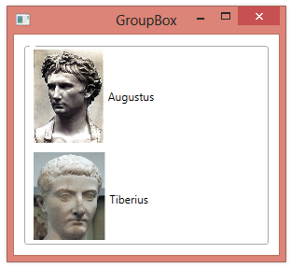](https://2000thingswpf.files.wordpress.com/2013/08/893-001.png)

To remove the gap you could just use a **Border** element instead of a **GroupBox**, changing its style to match the **GroupBox**.  You can also edit the default style of the **GroupBox**.

To edit the style of the **GroupBox**, start by right-clicking the **GroupBox**control in Visual Studio and select **Edit Template**, **Edit a Copy**.

[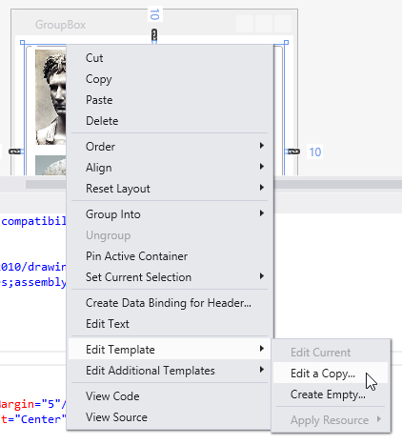](https://2000thingswpf.files.wordpress.com/2013/08/893-002.png)

Accept the default name for the style.

[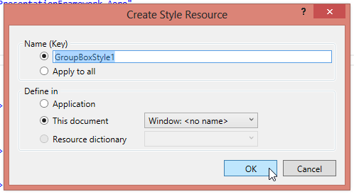](https://2000thingswpf.files.wordpress.com/2013/08/893-003.png)

Within the **Style** element, find the **OpacityMask**, near the bottom, and comment it out.

[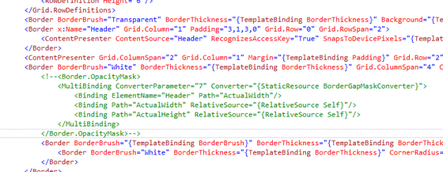](https://2000thingswpf.files.wordpress.com/2013/08/894-004.png)

Note that your **GroupBox** element is now using your modified copy of the style.

|  |  |
| --- | --- |
| 1  2 | <GroupBox Margin="10" BorderBrush="DarkGray"            Style="{DynamicResource GroupBoxStyle1}"> |

The **GroupBox** will no longer have the little gap where the header should go.  
[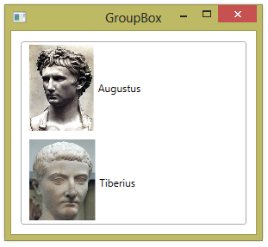](https://2000thingswpf.files.wordpress.com/2013/08/893-005.png)